How to handle exceptions in Spring Boot.
Before proceeding with exception handling, let us gain an understanding on the following annotations.

Controller Advice
The @ControllerAdvice is an annotation, to handle the exceptions globally.

Exception Handler
The @ExceptionHandler is an annotation used to handle the specific exceptions and sending the custom responses to the client.
You can use the following code to create @ControllerAdvice class to handle the exceptions globally −
package com.tutorialspoint.demo.exception;

import org.springframework.web.bind.annotation.ControllerAdvice;

@ControllerAdvice
public class ProductExceptionController {
}
Define a class that extends the RuntimeException class.
package com.tutorialspoint.demo.exception;

public class ProductNotfoundException extends RuntimeException {
private static final long serialVersionUID = 1L;
}
You can define the @ExceptionHandler method to handle the exceptions as shown. This method should be used for writing the Controller Advice class file.
@ExceptionHandler(value = ProductNotfoundException.class)

public ResponseEntity<Object> exception(ProductNotfoundException exception) {
}
Now, use the code given below to throw the exception from the API.
@RequestMapping(value = "/products/{id}", method = RequestMethod.PUT)
public ResponseEntity<Object> updateProduct() {
throw new ProductNotfoundException();
}
The complete code to handle the exception is given below. In this example, we used the PUT API to update the product. Here, while updating the product, if the product is not found, then return the response error message as “Product not found”. Note that the ProductNotFoundException exception class should extend the RuntimeException.
package com.tutorialspoint.demo.exception;
public class ProductNotfoundException extends RuntimeException {
private static final long serialVersionUID = 1L;
}
The Controller Advice class to handle the exception globally is given below. We can define any Exception Handler methods in this class file.
package com.tutorialspoint.demo.exception;

import org.springframework.http.HttpStatus;
import org.springframework.http.ResponseEntity;
import org.springframework.web.bind.annotation.ControllerAdvice;
import org.springframework.web.bind.annotation.ExceptionHandler;

@ControllerAdvice
public class ProductExceptionController {
@ExceptionHandler(value = ProductNotfoundException.class)
public ResponseEntity<Object> exception(ProductNotfoundException exception) {
return new ResponseEntity<>("Product not found", HttpStatus.NOT_FOUND);
}
}
The Product Service API controller file is given below to update the Product. If the Product is not found, then it throws the ProductNotFoundException class.
package com.tutorialspoint.demo.controller;

import java.util.HashMap;
import java.util.Map;

import org.springframework.http.HttpStatus;
import org.springframework.http.ResponseEntity;
import org.springframework.web.bind.annotation.PathVariable;
import org.springframework.web.bind.annotation.RequestBody;
import org.springframework.web.bind.annotation.RequestMapping;
import org.springframework.web.bind.annotation.RequestMethod;
import org.springframework.web.bind.annotation.RestController;

import com.tutorialspoint.demo.exception.ProductNotfoundException;
import com.tutorialspoint.demo.model.Product;

@RestController
public class ProductServiceController {
private static Map<String, Product> productRepo = new HashMap<>();
static {
Product honey = new Product();
honey.setId("1");
honey.setName("Honey");
productRepo.put(honey.getId(), honey);

Product almond = new Product();
almond.setId("2");
almond.setName("Almond");
productRepo.put(almond.getId(), almond);
}

@RequestMapping(value = "/products/{id}", method = RequestMethod.PUT)
public ResponseEntity<Object> updateProduct(@PathVariable("id") String id, @RequestBody Product product) {
if(!productRepo.containsKey(id))throw new ProductNotfoundException();
productRepo.remove(id);
product.setId(id);
productRepo.put(id, product);
return new ResponseEntity<>("Product is updated successfully", HttpStatus.OK);
}
}
The code for main Spring Boot application class file is given below −
package com.tutorialspoint.demo;

import org.springframework.boot.SpringApplication;
import org.springframework.boot.autoconfigure.SpringBootApplication;

@SpringBootApplication
public class DemoApplication {
public static void main(String[] args) {
SpringApplication.run(DemoApplication.class, args);
}
}
The code for POJO class for Product is given below −
package com.tutorialspoint.demo.model;
public class Product {
private String id;
private String name;

public String getId() {
return id;
}
public void setId(String id) {
this.id = id;
}
public String getName() {
return name;
}
public void setName(String name) {
this.name = name;
}
}
The code for Maven build – pom.xml is shown below −
<?xml version = "1.0" encoding = "UTF-8"?>
<project xmlns = "http://maven.apache.org/POM/4.0.0"
xmlns:xsi = "http://www.w3.org/2001/XMLSchema-instance"
xsi:schemaLocation = "http://maven.apache.org/POM/4.0.0
http://maven.apache.org/xsd/maven-4.0.0.xsd">

<modelVersion>4.0.0</modelVersion>
<groupId>com.tutorialspoint</groupId>
<artifactId>demo</artifactId>
<version>0.0.1-SNAPSHOT</version>
<packaging>jar</packaging>
<name>demo</name>
<description>Demo project for Spring Boot</description>

<parent>
<groupId>org.springframework.boot</groupId>
<artifactId>spring-boot-starter-parent</artifactId>
<version>1.5.8.RELEASE</version>
<relativePath/>
</parent>

<properties>
<project.build.sourceEncoding>UTF-8</project.build.sourceEncoding>
<project.reporting.outputEncoding>UTF-8</project.reporting.outputEncoding>
<java.version>1.8</java.version>
</properties>

<dependencies>
<dependency>
<groupId>org.springframework.boot</groupId>
<artifactId>spring-boot-starter-web</artifactId>
</dependency>
<dependency>
<groupId>org.springframework.boot</groupId>
<artifactId>spring-boot-starter-test</artifactId>
<scope>test</scope>
</dependency>
</dependencies>

<build>
<plugins>
<plugin>
<groupId>org.springframework.boot</groupId>
<artifactId>spring-boot-maven-plugin</artifactId>
</plugin>
</plugins>
</build>

</project>
The code for Gradle Build – build.gradle is given below −
buildscript {
ext {
springBootVersion = '1.5.8.RELEASE'
}
repositories {
mavenCentral()
}
dependencies {
classpath("org.springframework.boot:spring-boot-gradle-plugin:${springBootVersion}")
}
}
apply plugin: 'java'
apply plugin: 'eclipse'
apply plugin: 'org.springframework.boot'

group = 'com.tutorialspoint'
version = '0.0.1-SNAPSHOT'
sourceCompatibility = 1.8

repositories {
mavenCentral()
}
dependencies {
compile('org.springframework.boot:spring-boot-starter-web')
testCompile('org.springframework.boot:spring-boot-starter-test')
}
You can create an executable JAR file, and run the Spring Boot application by using the Maven or Gradle commands −
For Maven, you can use the following command −
mvn clean install
After “BUILD SUCCESS”, you can find the JAR file under the target directory.
For Gradle, you can use the following command −
gradle clean build
After “BUILD SUCCESSFUL”, you can find the JAR file under the build/libs directory.
You can run the JAR file by using the following command −
java –jar <JARFILE>
This will start the application on the Tomcat port 8080 as shown below −
Now hit the below URL in POSTMAN application and you can see the output as shown below −
Update URL: http://localhost:8080/products/3
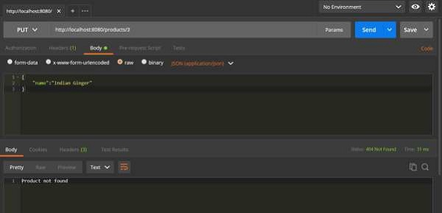

package com.javainuse;

import org.springframework.boot.SpringApplication;
import org.springframework.boot.autoconfigure.SpringBootApplication;

@SpringBootApplication
public class SpringBootHelloWorldApplication {

public static void main(String[] args) {
SpringApplication.run(SpringBootHelloWorldApplication.class, args);
}
}

package com.javainuse.controller;

import org.springframework.beans.factory.annotation.Autowired;
import org.springframework.web.bind.annotation.RequestMapping;
import org.springframework.web.bind.annotation.RequestMethod;
import org.springframework.web.bind.annotation.RestController;

import com.javainuse.exceptionhandling.ResourceNotFoundException;
import com.javainuse.model.Employee;
import com.javainuse.service.EmployeeService;
import com.javainuse.service.EmployeeServiceException;

@RestController
public class EmployeeController {

@Autowired
EmployeeService employeeService;

@RequestMapping(value = "/employee", method = RequestMethod.GET)
public Employee getEmpl() throws ResourceNotFoundException, EmployeeServiceException {

Employee emp = employeeService.getEmployee();

if (emp == null) {
throw new ResourceNotFoundException("Employee not found");
}
return emp;
}

@RequestMapping(value = "/employee2", method = RequestMethod.GET)
public Employee getEmp2() throws ResourceNotFoundException, EmployeeServiceException {

Employee emp = employeeService.getEmployeeNull();
if (emp == null) {
throw new ResourceNotFoundException("Employee not found");
}

return emp;
}

@RequestMapping(value = "/employee3", method = RequestMethod.GET)
public Employee getEmp3() throws ResourceNotFoundException, EmployeeServiceException {
try {
Employee emp = employeeService.getEmployeeException();
if (emp == null) {
throw new ResourceNotFoundException("Employee not found");
}
return emp;
} catch (EmployeeServiceException e) {
throw new EmployeeServiceException("Internal Server Exception while getting exception");
}
}
}

package com.javainuse.exceptionhandling;

import javax.servlet.http.HttpServletRequest;
import org.springframework.http.HttpStatus;
import org.springframework.web.bind.annotation.ControllerAdvice;
import org.springframework.web.bind.annotation.ExceptionHandler;
import org.springframework.web.bind.annotation.ResponseBody;
import org.springframework.web.bind.annotation.ResponseStatus;

@ControllerAdvice
public class ExceptionHandlerControllerAdvice {

@ExceptionHandler(ResourceNotFoundException.class)
@ResponseStatus(value = HttpStatus.NOT_FOUND)
public @ResponseBody ExceptionResponse handleResourceNotFound(final ResourceNotFoundException exception,
final HttpServletRequest request) {

ExceptionResponse error = new ExceptionResponse();
error.setErrorMessage(exception.getMessage());
error.callerURL(request.getRequestURI());

return error;
}

@ExceptionHandler(Exception.class)
@ResponseStatus(value = HttpStatus.INTERNAL_SERVER_ERROR)
public @ResponseBody ExceptionResponse handleException(final Exception exception,
final HttpServletRequest request) {

ExceptionResponse error = new ExceptionResponse();
error.setErrorMessage(exception.getMessage());
error.callerURL(request.getRequestURI());

return error;
}

}

package com.javainuse.exceptionhandling;

public class ExceptionResponse {

private String errorMessage;
private String requestedURI;

public String getErrorMessage() {
return errorMessage;
}

public void setErrorMessage(final String errorMessage) {
this.errorMessage = errorMessage;
}

public String getRequestedURI() {
return requestedURI;
}

public void callerURL(final String requestedURI) {
this.requestedURI = requestedURI;
}
}

package com.javainuse.exceptionhandling;

public class ResourceNotFoundException extends Exception {

private static final long serialVersionUID = -9079454849611061074L;
public ResourceNotFoundException() {
super();
}

public ResourceNotFoundException(final String message) {
super(message);
}

}

package com.javainuse.model;

public class Employee {
private String empId;
private String name;
private String designation;
private double salary;

public Employee() {
}

public String getName() {
return name;
}

public void setName(String name) {
this.name = name;
}

public String getDesignation() {
return designation;
}

public void setDesignation(String designation) {
this.designation = designation;
}

public double getSalary() {
return salary;
}

public void setSalary(double salary) {
this.salary = salary;
}

public String getEmpId() {
return empId;
}

public void setEmpId(String empId) {
this.empId = empId;
}

}

package com.javainuse.service;

import org.springframework.stereotype.Service;
import com.javainuse.model.Employee;

@Service
public class EmployeeService {

public Employee getEmployee() throws EmployeeServiceException {
Employee emp = new Employee();
emp.setName("emp1");
emp.setDesignation("manager");
emp.setEmpId("1");
emp.setSalary(3000);

return emp;
}

public Employee getEmployeeNull() throws EmployeeServiceException {

return null;
}

public Employee getEmployeeException() throws EmployeeServiceException {

throw new EmployeeServiceException();
}

}

package com.javainuse.service;

public class EmployeeServiceException extends Exception {

private static final long serialVersionUID = -470180507998010368L;

public EmployeeServiceException() {
super();
}

public EmployeeServiceException(final String message) {
super(message);
}
}

Compile and the run the SpringBootHelloWorldApplication.java as a Java application.
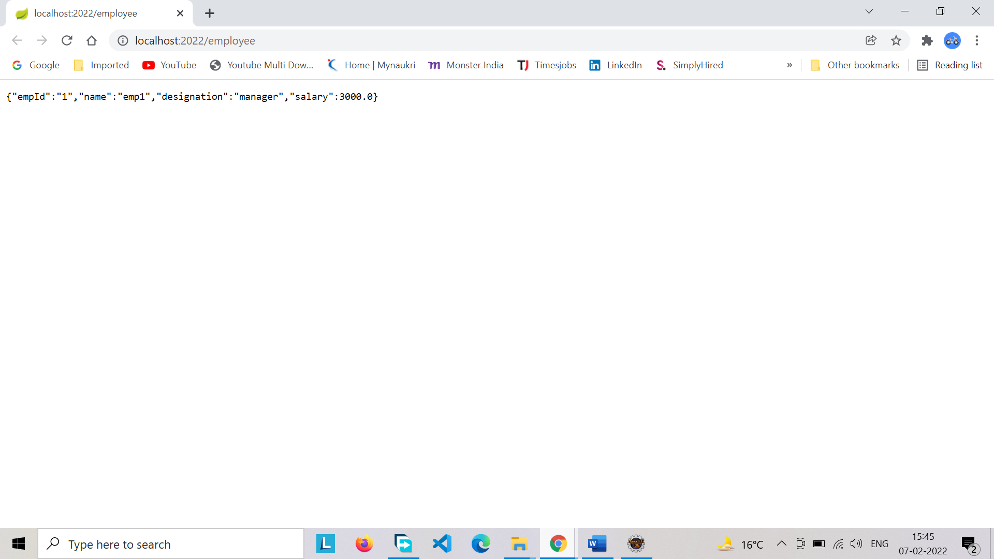
Using postman go to localhost:8080/employee2 Employee is not found, so ResourceNotFoundException is thrown. Response code is sent as 404.
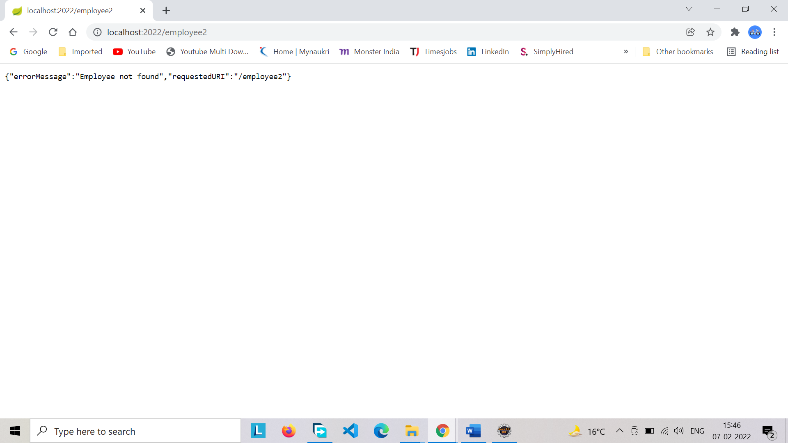

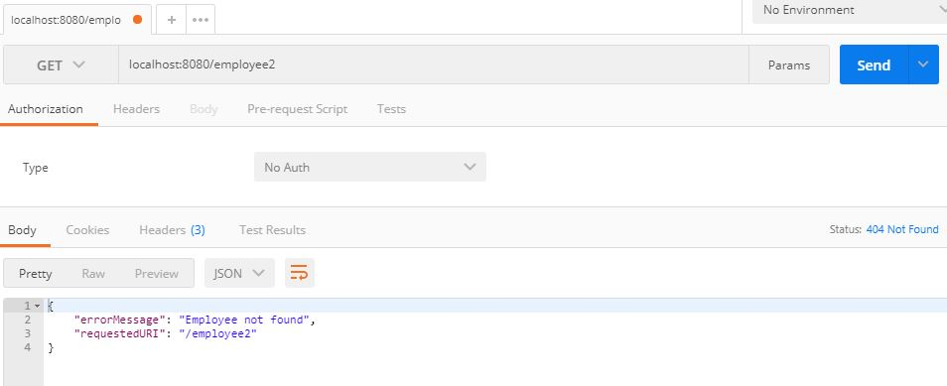
localhost:8080/employee3 EmployeeServiceException is thrown. Response code is sent as 500.
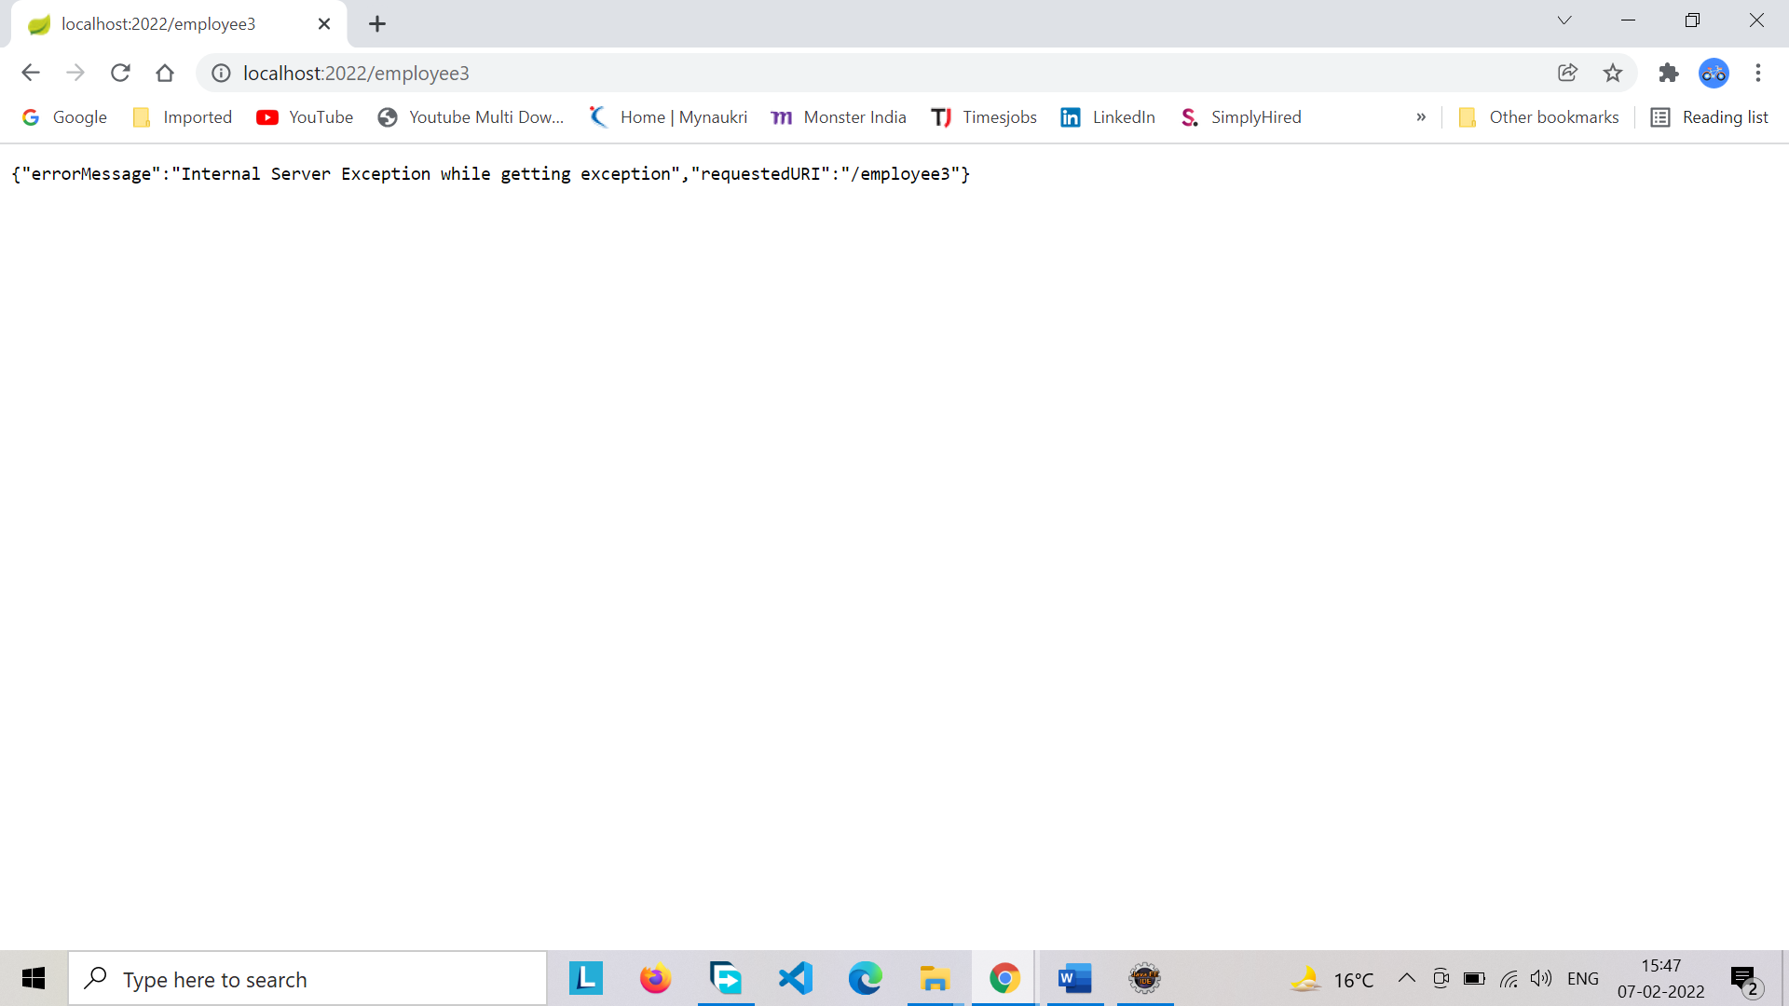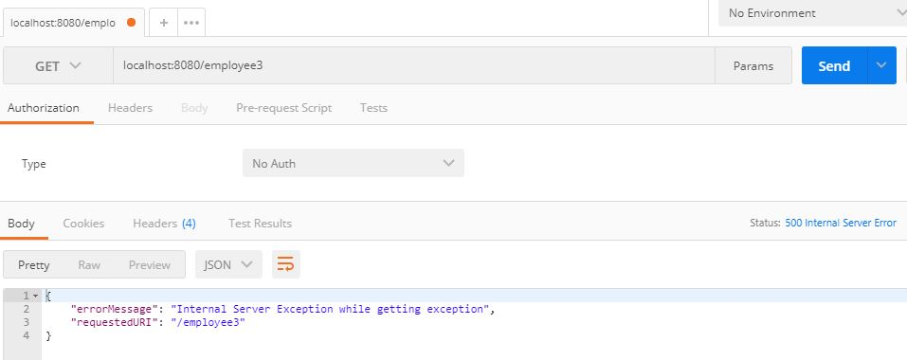

<?xml version="1.0" encoding="UTF-8"?>
<project xmlns="http://maven.apache.org/POM/4.0.0" xmlns:xsi="http://www.w3.org/2001/XMLSchema-instance"
xsi:schemaLocation="http://maven.apache.org/POM/4.0.0 http://maven.apache.org/xsd/maven-4.0.0.xsd">
<modelVersion>4.0.0</modelVersion>

<groupId>com.javainuse</groupId>
<version>0.0.1-SNAPSHOT</version>
<packaging>jar</packaging>

<name>SpringBootHelloWorld</name>
<description>Demo project for Spring Boot</description>

<parent>
<groupId>org.springframework.boot</groupId>
<artifactId>spring-boot-starter-parent</artifactId>
<version>1.4.1.RELEASE</version>
<relativePath /> <!-- lookup parent from repository -->
</parent>

<properties>
<project.build.sourceEncoding>UTF-8</project.build.sourceEncoding>
<project.reporting.outputEncoding>UTF-8</project.reporting.outputEncoding>
<java.version>1.8</java.version>
</properties>

<dependencies>
<dependency>
<groupId>org.springframework.boot</groupId>
<artifactId>spring-boot-starter-web</artifactId>
</dependency>

<dependency>
<groupId>org.springframework.boot</groupId>
<artifactId>spring-boot-starter-test</artifactId>
<scope>test</scope>
</dependency>

</dependencies>

<build>
<plugins>
<plugin>
<groupId>org.springframework.boot</groupId>
<artifactId>spring-boot-maven-plugin</artifactId>
</plugin>
</plugins>
</build>

<artifactId>spring-boot-exceptionhandling</artifactId>
</project>

Download Source Code
Download it -
Exception Handling using Spring Boot

